**Membership Utility Installation Notes**

The Membership Utility has several core functions:

query a User to see which Permission Set(s), Public Group(s), and Queue(s) he/she belongs to query a Permission Set, Public Group, or Queue to see a list of its members. It leverages 3 hidden multi picklists on the User record that track Permission Set(s), Public Group(s), and Queue(s) and a batch that runs nightly to update these fields with any changes in membership.

It is manifested in several ways:

* a Visualforce page to query a User to see which Permission Set(s), Public Group(s), and Queue(s) he/she belongs to;
* 3 Visualforce pages, one each to query a Permission Set, Public Group, and Queue to see a list of their respective members;
* a component on a Salesforce System Case to automatically query the Profile, Permission Sets, Public Groups, and Queues of the Case Contact reporting on the 3 hidden multi picklists

Version 2 will replace the 3 multi picklists with a Custom Object and Related List that tracks "SObjects", including Permission Set(s), Public Group(s), and Queue(s). This will actually require a Junction Object since the relationships are many-to-many. It will be linked to the SObjects in Application Inventory.

Folder Contents:

* ReadMe.txt – describes core functions
* src – source folder created using eclipse on checkout from a dev org; may be used to deploy to another org.

Alternative to using eclipse or Ant—simply copy+paste apex code into salesforce using the SF text editor.

Required fields on User object:

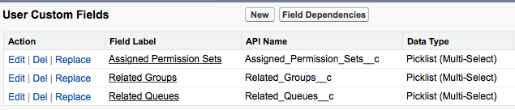

Required Link on Case object:

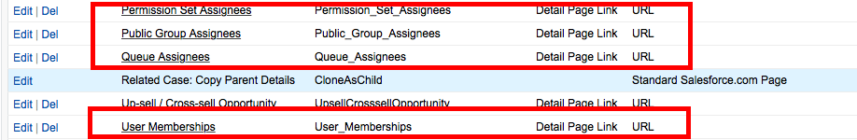

To create Links:

Go to Setup,

Build

Customize

Cases

Buttons,Links,andActions

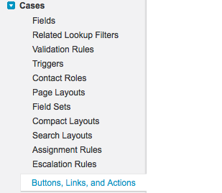

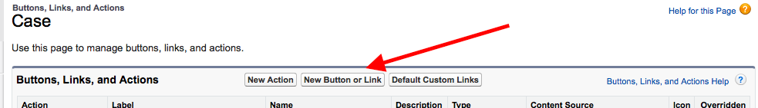

1) Permission Set Assignees

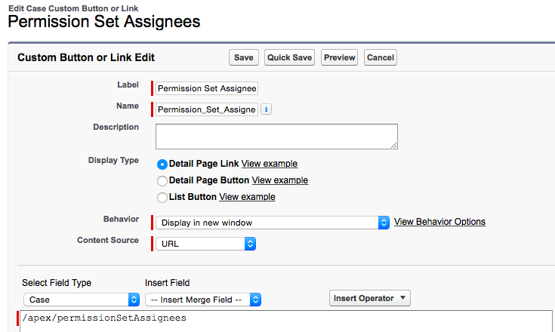

2) Public Group Assignees

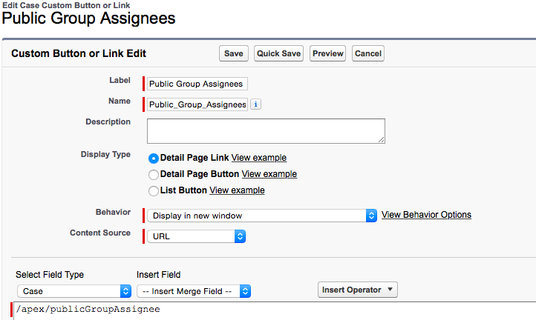

3) Queue Assignees

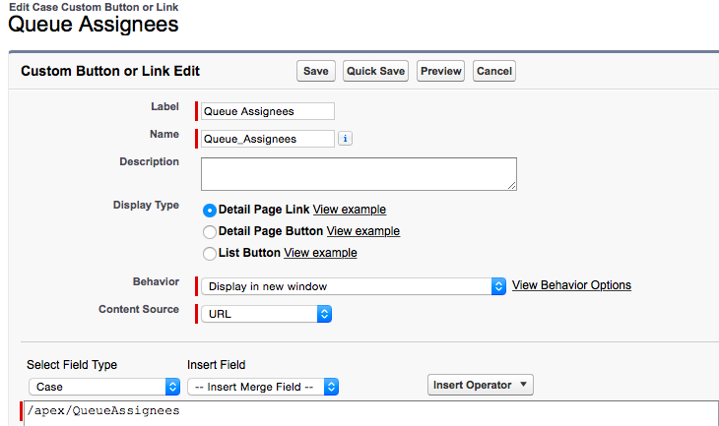

4) User Memberships

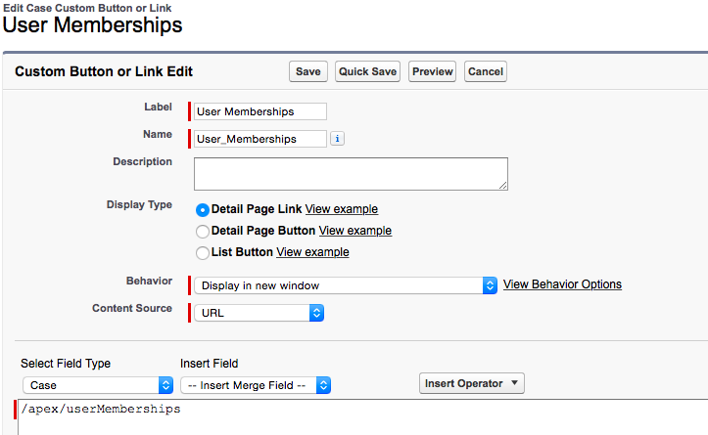

Add above Links to the Case Page Layout Custom Links by dragging …

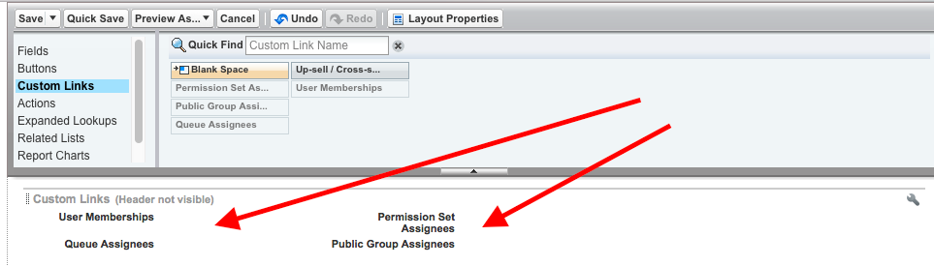

VF Page on Case Page Layout

Go to Cases … Page Layouts, and select/edit the desired Page Layout.

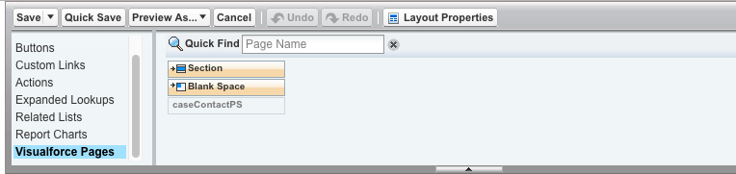

Create a New Section by dragging the “Section” icon/button to the page and label it “Profile and Permission Sets”

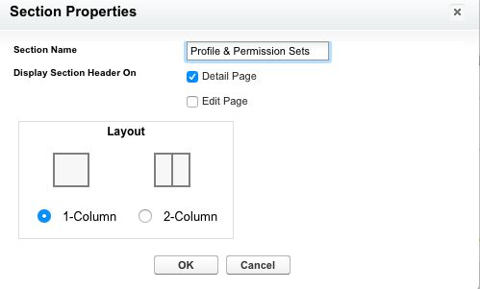

Then Drag the VF “caseContactPS” to the newly created section.

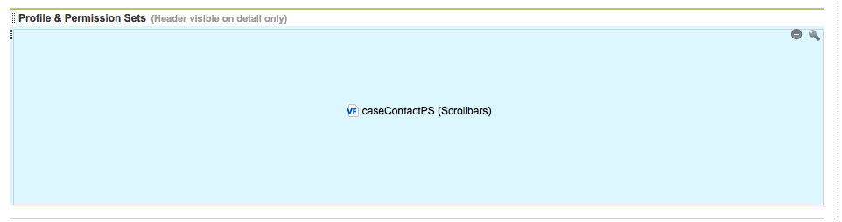

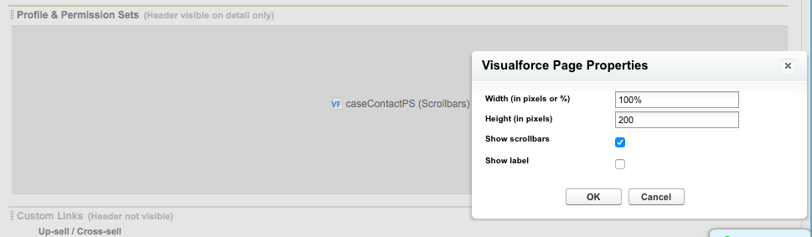

To Schedule nightly job: fasUserRelatedGroupingsScheduler, run on DeveloperConsole the following script:

fasUserRelatedGroupingsScheduler sh1 = new fasUserRelatedGroupingsScheduler();

String sch = '0 45 22 ? * MON-FRI'; // 10:00PM Monday thru Friday

String JobId = system.schedule('CEO User Related Groupings Batch Update', sch, sh1);

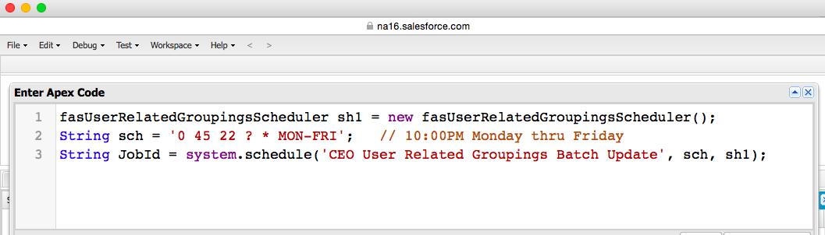

Sample Output:

